This is a demo test.
Please read the instructions carefully.

Fill in your name, admin no. and group below:
Name:  Zara | Admin No.  194123U | Group:  2

Do the tasks in the virtual computers and use the snipping tool (or other screen capture tool) to copy the required result and paste it into the answer box.

Question 1
Create a RAID 1 drive in the Windows Server NYP-DC1. The drive must have the following parameters:
Volume name = your admin no.
Drive size = any size
Drive letter = any letter
File system = NTFS
You can use existing disks or add your own virtual disks.
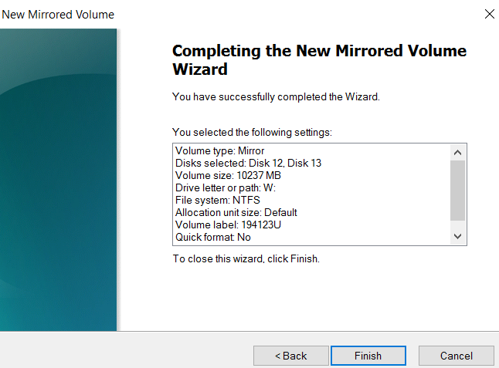
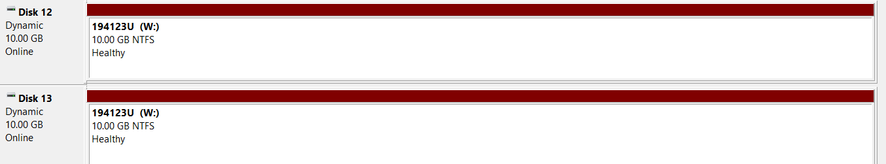

Paste a screen shot of Disk Management showing your Raid 1 volume

